GESTURE RECOGNIZER

Agenda: Here we are creating a basic program which is used to control the device by recognizing the gestures of human hand.

* Firstly we are starting the program by using **open cv** along with the mediapipe.
* Open CV is a great tool for image processing and performing computer vision tasks and it is a open source library that can be used to perform tasks like face detection, object tracking, landmark detection and much more. It supports multiple languages including python, java, c++.
* Here we are using open CV to capture the hand gestures by using neural network mechanism by assigning various key points to it.
* As of now we are all know that we have multiple ways to operate/run a electronic device like voice assistant , keyboards, manual search and etc,.
* One of the important key in Gesture recognizer is works to drive an electronic device’s by assigning the various gestures to the respective operations.
* Hand gesture recognition is a technology that is becoming increasingly relevant, given the recent growth and popularity of Virtual and Augmented Reality technologies
* Here I am using Arduino ide to install the firmeta code to connect with the gestures
* Based on the gestures led will be turn on and off i.e we can use it as home automation by using the relay board
* Not only switching, it can be used to run the various games by using gestures and remote operations will be done by this type of operation.
* It is one key aspect to HCI, allowing for two-way interaction in virtual spaces.
* Hence, starting with the most basic interaction, we would want to use our hands to move and ‘touch’ things. In other words, we need hand gesture recognition as the basis of HCI in virtual reality.
* Most people nowadays own a laptop with a front-facing camera. If we could tap into this, we could possibly bring a more natural method of interaction to the masses. Moreover, as virtual reality devices become more common, the laptop camera may also become a viable complementary interaction device
* 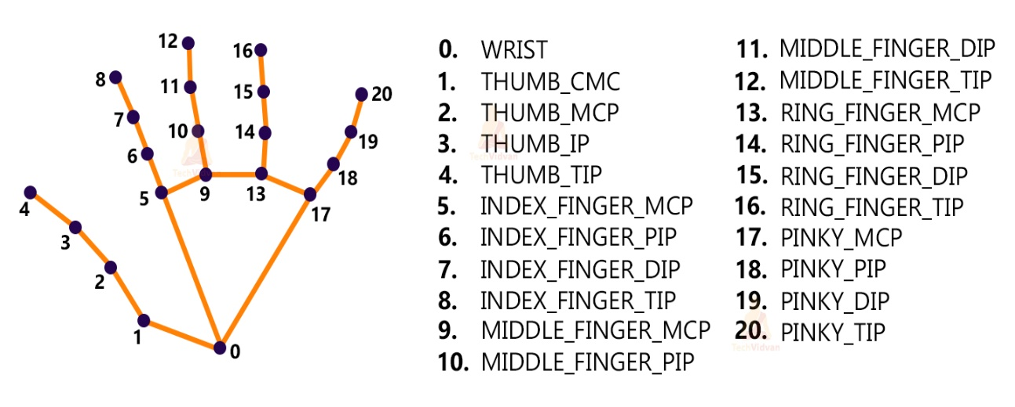We’ll first use MediaPipe to recognize the hand and the hand key points. MediaPipe returns a total of 21 key points for each detected hand.

,

Ex: We can upgrade the code by connecting the Arduino by adding home automation source code with gesture recognizer to use it as home automation(operating the home appliances by using gestures)

NEURAL NETWORK SYSTEM